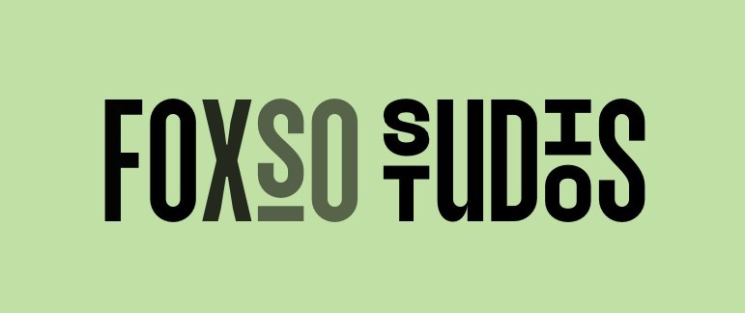

Commission Intake Form

(I am only accepting united states local commissions at this time)

**I WILL NOT DO ANY, NSFW FURSUITS, SCALIES, MECH, SEMI REALISTIC OR REALISTIC**

**I WILL DO, TOONY, SEMI TOONY, KEMONO, AND HYPER EXPRESSIVE**

**I am always open to learning through commissions! I do not tolerate any weird or disrespectful behavior,**

**this will guaranty an automatic deny to any quotes from**

**me.**

# Initial measurements/ Information:

Full legal first name: Full legal last name: Ship to address: Contact phone number: Preferred contact email:

How old are you (must be over 15):

What form of fursuit or you looking to commission?:

(ex. Partial (full or mini), Full body Digi, just paws, just feet, just head, or just tail)

Name of fursona:

Picture/ pictures of fursona ref sheet:

(if not detailed enough, I will turn you away until I have a reference I can use to make your suit exactly how you want it!)

Time limit (if any):

Your budget:

What is your best way of constant communication for work progress updates?:

## !!ALL IN INCHES!!

Head circumference measurement:

(for commissions including heads only have to fill this out)

(use a flexible tape measure to wrap around the widest part of your head. The widest part of your head is usually about half an inch above your eyebrows or ears, and in the middle of your forehead, just above your ears. You can also wrap the tape around the most prominent part of the back of your head)

Wrist measurements:

(for commissions including paws only have to fill this out)

(Wrap the tape around your wrist at its widest part, then note the measurement. Add half an inch to determine your bracelet size.)

Arm length:

(for commissions including sleeves only have to fill this out)

(use a tape measure to find the distance between the tip of your shoulder bone and the tip of your wrist, while your arm is relaxed and hanging by your side)

## Shoe size:

(for commissions including feet paws only have to fill this out)

(specify, if its euro, men's, or women's, or children's)

**Fursuit parts!**

**Head:**

(for commissions including heads only have to fill this out)

**(Plush noses, automatically lined unless specified otherwise, plush tongue and 3d printed teeth)**

Species:

Facial expression: Desired fur colors:

(either from Bigz or Howl fabrics, provide fur name or picture with fur name, or put artists choice if you aren't sure)

Any specific materials you’d like to add:

(ex: minky, uv, or any other material I need to be aware of) Removable/exchangeable eyelids:

(+1.00 for each pair, and +5.00 initial) Removable/exchangeable tongue:

(.50$, for each tongue, and +1.00 initial) Any extra accessories:

(ex, hat, plant, earrings, facial piercings, etc)(price in quote form) Pickable nose?:

(+.50)

Teeth?:

(plush or acrylic? Acrylic +2.00$)

List any other specific features you’d like that are not mentioned here:

# Sleeves/Paws:

(psa raptor or any dino feet auto comes with only 3 toes on the paws)

(for commissions including sleeves and paws only have to fill this out)

# Sleeves:

Do you want sleeves?:

(full partial)

Desired fur colors:

(either from Bigz or Howl fabrics, provide fur name or picture with fur name, or put artists choice if you aren't sure)

Any complicated patterns? (Specify what pattern if applicable)

Do you want it lined?

List any other specific features you’d like that are not mentioned here:

# Paws:

**(Comes fully lined, and with a lip to protect the raw fur edge)**

Do you want paws?:

Desired fur colors:

(either from Bigz or Howl fabrics, provide fur name or picture with fur name, or put artists choice if you aren't sure)

Desired minky:

(either from Bigz or Howl fabrics, provide fur name or picture with fur name, or put artists choice if you aren't sure)

Any complicated patterns?: (Specify what pattern if applicable)

Acrylic claws: (yes or no, +2.00)

Plush claws: (yes or no, free)

How many fingers?:

(3-5 fingers depending on species and your personal preference)

List any other specific features you’d like that are not mentioned here:

**Tails:**

(for commissions including tails only have to fill this out)

Desired fur colors:

(either from Bigz or Howl fabrics, provide fur name or picture with fur name, or put artists choice if you aren't sure)

Any complicated patterns?: (Specify what pattern if applicable)

Desired length:

Will it drag against the floor? (floordraggers): (+20)

Would you like the tail separated from the suit via belt, or connected to the suit permanently?:

List any other specific features you’d like that are not mentioned here:

**Feetpaws:**

(for commissions including feetpaws only have to fill this out)

Ankle length or full digitigrade, (to calf)?:

Desired fur colors:

(either from Bigz or Howl fabrics, provide fur name or picture with fur name, or put artists choice if you aren't sure)

Any complicated patterns?: (Specify what pattern if applicable)

Outdoor or indoor paws?: (indoor +10$)

Sandles for indoor paws?: (yes or no, +7$)

Claws?:

(yes or no, plush by default)

List any other specific features you’d like that are not mentioned here:

(psa raptor or any dino feet auto comes with only 3 toes on the feet)

Full body (digitigrade only) (currently closed)

**Extras:**

**Allergies:**

**!!My house includes 3 cats and i am constantly in contact with dogs, there is NO smoking or any items that would cause a smell or stain to the suit.**

**Please list ALL possible allergies so I can best keep away or not use those items. I am NOT responsible for any allergic reactions after the final quote form is signed!!**

# MISC:

Are there any accessories or character items you specifically want me to make in addition to your suit?

**Package details:**

*Comes with a care instructions post card

*Comes with goodies, art of your oc, candy, stickers, etc (you can opt out of this)

*A free laminated badge

*every item is protected with packing materials, as well as placed in clean garbage bags for easier shipping

I have the right to turn you down if I feel the fursuit is out of my skill level Any further questions?: